1.15: a) If a meter stick can measure to the nearest millimeter, the error will be about 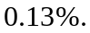b) If the chemical balance can measure to the nearest milligram, the error will be about 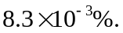 c) If a handheld stopwatch (as opposed to electric timing devices) can measure to the nearest tenth of a second, the error will be about 